Report Date: 20/11/2023
Compiled by:
Kevin Kerin CMIOSH IMaPS MIIRSM OSHCR
Joseph Kerin LLB AIOSH
Universal Safety Practitioners Limited
Annual Health & Safety Performance Review 2023
and proposed Action Plan for 2024
1.0 Executive Summary
This annual report details the progress made against the Health and Safety initiatives agreed in the 2023 Action Plan, as well as the dynamic development of the agreed actions, with enhanced Health and Safety works.
This report also details the ongoing initiatives identified by West London Waste Authority in their proposed Action Plan for 2024, as part of the organisations’ continued efforts to strive for best practice in the field of occupational Health and Safety risk management.
Whilst this report deals with the advertised high-level achievements and initiatives in the form of developed action plans, the report does not deal with issues such as the management of contractors, which not seen as a dedicated action plan for development, is managed on an ongoing basis with direct involvement of the WLW Health and Safety Advisors working both WLW staff and contractors for ongoing safe systems of work.
1.2 2023 H&S Performance
2023 has seen a strong positive performance in the further development and enhancement of the WLW Health and Safety management system. This included the provision of Health and Safety advice and support for other Boroughs outside of the traditional levels of support given to both Abbey Road and West Drayton sites. This is an ongoing initiative which will allow the setting of parity across the identified Boroughs with the Health and Safety achievements at Abbey Road and West Drayton sites.
The previous developments as detailed in historic action plans has provided a strong platform on which the organisation continues to maintain and enhance the present developed Health and Safety management system, with ongoing reviews and updates of the WLW Health and Safety Policy as well as the supporting Policy-level guidance documents and risk assessments.
1.3 Progress Made Against the 2023 Action Plan
The initiatives laid out within the organisations 2023 Action Plan continued to be driven through the process of risk assessment, helping to ensure safe systems of work are fully developed and implemented through a programme of information, training and supervision; as detailed in the headline requirements of the organisation’s Health and Safety Policy and associated supporting guidance documents.
As detailed in the 2023 Action Plan table (figure 1) in this section, significant progress has been made against this action plan in the majority of areas, with finalising and implementation points required to complete these actions.

Two areas which require further action to complete on the action plan were:
- General enhancement of H&S training across the organisation (currently 70% complete)
- Development of H&S knowledge for identified managers and chargehands to IOSH Managing Safely and IOSH Working Safely courses (25%).
Providers for these courses have been supplied. Once these providers and costings have been reviewed, these courses will be booked and completed.
As an ongoing initiative the organisations’ hazard reporting process continues to go from strength to strength with an increase in the number of hazards being identified and addressed. Whilst this could easily be seen as a detrimental aspect, this increase in the identification of hazards (as seen in table “2021-2023 Hazard Cards Raised”) should be seen as only made possible through the ongoing push on this initiative and support given to WLW staff.
Figure 1

2.0 What We Have Achieved – In Detail
Progress Made Against the 2023 Action Plan
2.1 Creation of an ‘active travel framework’ (90% complete)
It was identified at the time of creating the 2023 Action Plan that some members of the organisation actively travel to work (i.e. travelling by foot, bike etc). Travelling via these modes creates risks in respect of personal safety. As a result, we have created active travel risk assessment and associated guidance documentation.
Currently, it is at 90% completion, as we are going through the formal consultation process with the organisation, prior to it being disseminated.
2.2 General enhancement of H&S training across the organisation (70%)
Apart from the mandatory H&S training which is required across the sites (i.e. Manual Handling, Asbestos Awareness etc) we have been working on providing additional training modules to staff on various items.
To date, we have completed ‘engagement and management of contractors’ training, which provided managers with information on the HSE’s approach to this important process, from the initial engagement of contractors, through to on-site supervision, the risk assessment process etc.
Additionally, the staff at the Abbey Road site are in the process of completing customer service training which will provide them with additional tools in respect of providing quality customer service, as well as dealing with upset customers and complaints.
There is still some training to be completed, specifically in respect of ‘Permit-to-Work’ training, which sits alongside the engagement and management of contractor’s framework. We are liaising with all 3 of the sites in respect of getting some dates to complete this training.
2.3 Enhancement of the organisation’s culture in respect of hazard reporting (100%)
West London Waste Authority have had for several years, a robust electronic hazard reporting system. This system allows members of staff to capture hazards in the moment and log this on the system. We then use this data and conduct trend analysis, to ascertain route causes and implement initiatives in order to reduce the instances of these hazards occurring.
Historically, we have found that not the entirety of the Abbey Road staff has been reporting on the system. As part of the organisation’s continual strive for a positive Health and Safety culture, works have been undertaken at a site level perspective to ascertain the barriers which are preventing all members of staff reporting. We have seen over the last 3 months that more members of staff are now reporting on the system.
2.4 Ongoing Circular economy support with enhancements on the H&S framework around all circular economy initiatives (100%)
Circular Economy for the organisation continues to grow, with the introduction of the laptop repair station within the Abbey Road site (referred to as the ‘Fixing Factory’). Additionally, we are working close with the organisation’s Project Management Team in respect of the Acton site, to ensure that the works which need to be undertaken to change the site into a Circular Economy Hub, are done so in a compliant manner, in line with legislation and HSE best practice.

2.5 Development of H&S Knowledge for identified Managers and Chargehands to IOSH Managing Safely/ Working Safely Courses (25%)
Some positive works were previously done in respect of this item, by gathering information on the number of delegates for the courses, and quotations provided from various training providers. However, with the introduction of both Townmead Road and Central Depot, it has meant that the quotations provided are now redundant. We are currently in the process of ascertaining the numbers of personnel who now need this training and will go back out to the market to gain quotations for this new, elevated number. Due to the importance of having this item closed out, our attention in the short term is to ensure that we obtain the quotations and have this training rolled out in early 2024.
2.6 Develop a programme for lone and transient working throughout the organisation (90%)
Much like the ‘active travel’ framework, a positive amount of works has been completed including lone working risk assessment and guidance documentation. We are now in the process of conducting formal consultation with the organisation to ensure that the information contained within these important documents aligns and will be closed out by the end of 2023.

3.0 Health and Safety Action Plan for 2024
The table below outlines the organisations 2024 Health and Safety action plan initiatives. The initiatives contained in the 2024 action plan have been as a result of conversations with various members of the organisation, to ascertain areas where the organisation would like to see improvements, as well as areas that USP believe should be included as part of the organisations focus for 2024.

3.1 Health and Safety Action Plan 2024
After consultation with various members of the West London Waste Authority’s Senior Leadership Team, the following action plan has been drafted for review, which identifies the items which the organisations wish to embark on in 2024. All items contained

Ref | Action required | Person(s) Responsible | Agreed Timescale | Further action details
1 | Creation and implementation of a Behavioural Safety Framework | H&S Advisor. | Jan24-Dec24 | H&S in the workplace is influenced by a number of factors including the organisations’ environment, management attitude, commitment to the nature of the job and personal attributes of the worker.  Safety-related behaviour can be changed by addressing such influences. There are some fundamental elements including policies, systems, assessing and improving management performance and operational factors, training and design.  This item will leverage the existing works which have taken place in respect of the Health and Safety culture for the organisation, ensuring that the organisation continues to strive for Health and Safety excellence.
2 | Review and enhancement of existing Health and Safety Management System | H&S Advisor | Jan24-Dec24 | As West London Waste as an organisation continues to grow, the organisations’ Health and Safety Management system needs to grow with it, to ensure that the organisations process are encapsulating in the right governance document.  As a result, we propose a review and enhancement of the organisations’ overarching Health and Safety governance documentation, to ensure that it remains tailored to the organisation.
3 | Introduction of new starter Health and Safety sign-off framework | H&S Advisor | Jan24-Dec24 | With the great deal of Health and Safety documentation which is in circulation within the organisation, it is imperative that a there is a rigid framework in place for sign-off of Health and Safety documentation for all new employees to the organisation.  This will take the form of process documentation, as well as new employee Health and Safety handbooks, which will include the enhancement Health and Safety documentation (as highlighted in Ref 2 of this action plan), along with all other associated documentation (role dependent).
4 | H&S Project Training | H&S Advisor | Jan24-Dec24 | With our organisation being involved in Health and Safety governance for project works which are falling within the scope of the Construction (Design and Management) Regulations, we propose formal training in respect of wider project Health and Safety governance, thus providing the organisations Project Management Team with information and processes on these projects, given them a wider breadth of knowledge of project safety.
5 | Providing Health and Safety Assistance to other Boroughs | H&S Advisor | Jan24-Dec24 | As our works this year included providing Health and Safety assistance to sites under the control of LBRUT, West London Waste Authority are producing Service Level Agreements with other Boroughs, which may include the provision of Health and Safety support from Universal Safety Practitioners, to assist where required, to ensure compliance across the board.
6 | Development of H&S knowledge for identified Managers and Chargehands to IOSH Managing Safely / Working Safely courses. | H&S Advisor | Jan24-March24 | As noted above, we have been unable to deliver this item from the 2023 Action Plan, due to the introduction of the other sites which we are now providing assistance to. Once we have been provided with the final numbers and appropriate courses, we will be ensuring that these courses are booked and delivered.
7 | Environmental management framework and accreditation. | H&S Advisor | Jan24-Dec24 | More and more organisations are tackling environmental impacts by ensuring that their existing management system includes what the organisation does from an environmental perspective. The most common way to do this is to create a system which is benchmarked to the ISO14001 system, along with suitability assessment schemes through either BREEAM or CEEQUAL, which shows external partnering organisations, WLWA’s commitment to environmental issues.

4.0 Health and Safety Statistics (2021-2023)

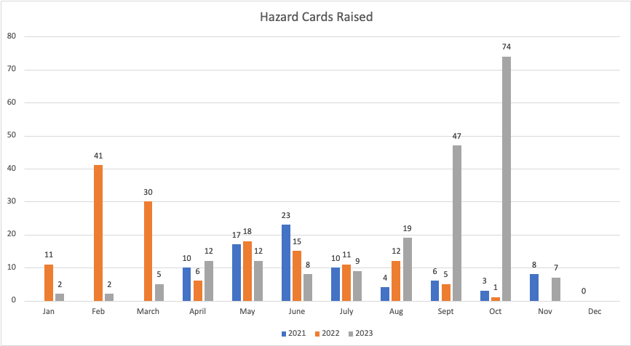

This table confirms the hazard cards completed in 2021-2023. As the graph shows that there has been a fluctuation across the 3-year span in the number of hazard cards raised at the Abbey Road site. There has been a more recent spike in hazard card numbers showing in September and October (2023).
This is partially due to the fact that we are now seeing more members of staff reporting, compared to earlier in the year, driven in part by a continued push on the initiative with site staff and an increase in the understanding of the value in hazard reporting across the site.

Additionally, we have seen repeated hazard cards being raised in respect of abusive behaviour towards staff, traders not wearing PPE as well as them not abiding by site rules. Discussions have taken place, with initiatives being launched on site to address these issues head-on.
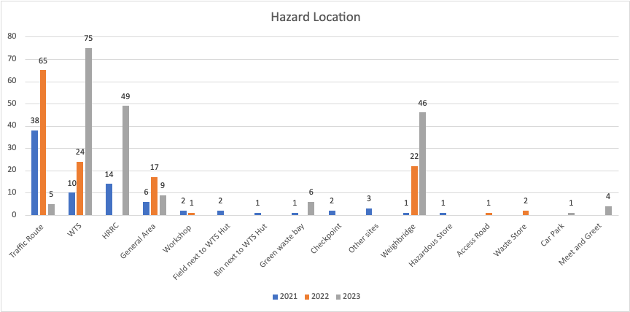
In respect of ‘hazard Location’, the Weighbridge, Waste Transfer Station and HRRC continue to be the highest areas in respect of hazards reported. This is not unsurprising considering that these are the main areas of site where we see a high footfall and is consistent with previous Authority reports which have confirmed the same.

We will continue to target these areas and issues raised by working closely with the staff in each of these areas, to bring the number of hazard cards down.

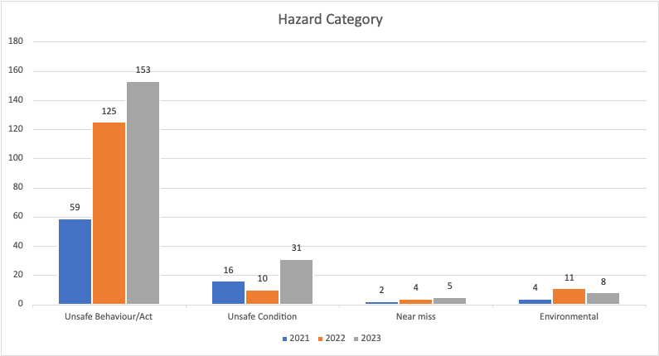

In respect of the ‘hazard Category’ we continue to see ‘Unsafe Behaviour/Act’ being the main category identified. Most hazard cards classified as such, relate to visitor behaviour to the site from both traders and residents, and typically consist of the following:
- Abusive behaviour
- Driving related issues
- Not complying with site rules (no use of PPE, smoking, not using walkways etc).

Unsafe condition reporting sees a significant growth in the numbers records against the three-year cycle.

A slight reduction in areas specific to environmental hazards is showing around across the three-year cycle.

Again, it should be recognised that the overall raising of the hazard categories across this time span is due significantly the numbers of hazards raised, due considerably to the raising of awareness by WLW staff.

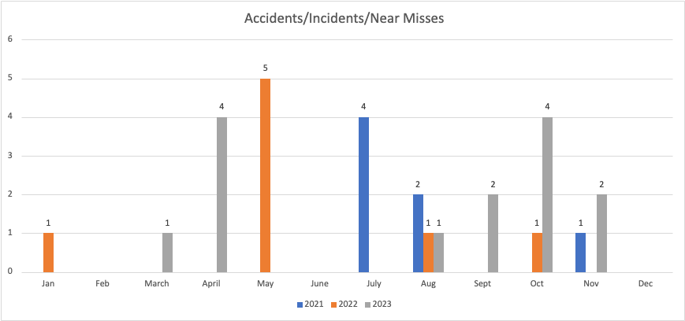

The above table shows a fluctuation of figures relating to accidents, incidents and near misses across the period 2021-2023. In 2023, there were a total of 14 accidents/ incidents, with both October and April recording the highest numbers of accidents/incidents/near misses (4).

From a category perspective, the main categories that these were raised against related to:
- Minor injury (no First Aid required)
- Fire
- Property Damage (visitors, traders)
- In 2023 an additional category was introduced into the programme to track formally any accident, incidents or near misses occurring involving visitors to the site. The 3 accident/incident/near misses categorised as such related to customers/traders coming into contact with other vehicles (low speed) or fixed items at the site.

There have been 3 fire situations in 2023, which related to fires in the small WEEE bay in the HRRC, and waste in the Waste Transfer Station.

There has been one lost time accident where a member of staff sustained a manual handling injury which resulted in them having some days away from work, and 1 instance where minor first aid was required.

